Birla Vishvakarma Mahavidyalaya

Engineering College

[An Autonomous Institution]

Project Report

On

**E-Commerce website**

Under the course of

**DESIGN ENGINEERING -3CP08**

B. E. Semester – VI

**(Computer Engineering)**

**Submitted by:**

**19CP067 JAINIL PATEL**

**19CP068 VISHAKH DESAI**

**Academic year: (2021-2022)**

**CERTIFICATE**

This is to certify that the students namely, **Jainil Patel(19CP067), Vishakh Desai (19CP068)** of ***B. E. (Computer Engineering) Semester VI*** have successfully completed the course work and related tasks for the course of **Design Engineering 3CP08** during the academic term ending in the month of May 2022.

Date: __________

Place: __________

(Faculty Guide) Head of Department

**Introduction to Engineering Design**

**1. What is design thinking?**

“Design Thinking is a human-centered approach to innovation that draws from the designer's toolkit to integrate the needs of people, the possibilities of technology, and the requirements for business success.”

Design thinking is “human-centered,” which means that it uses evidence of how consumers (humans) actually engage with a product or service, rather than how someone else or an organization thinks they will engage with it. To be truly

human-centered, designers watch how people use a product or service and continue to refine the product or service in order to improve the consumer’s experience.

This is the “iterative” part of design thinking. It favors moving quickly to get prototypes out to test, rather than endless research or rumination.

In contrast to traditional problem-solving, which is a linear process of identifying a problem and then brainstorming solutions, design thinking only works if it is iterative. It is less of a means to get to a single solution, and more of a way to continuously evolve your thinking and respond to consumer needs.

**2. Explain the Design Thinking phase with a diagram.**

There are total 5 phase in Design Thinking.

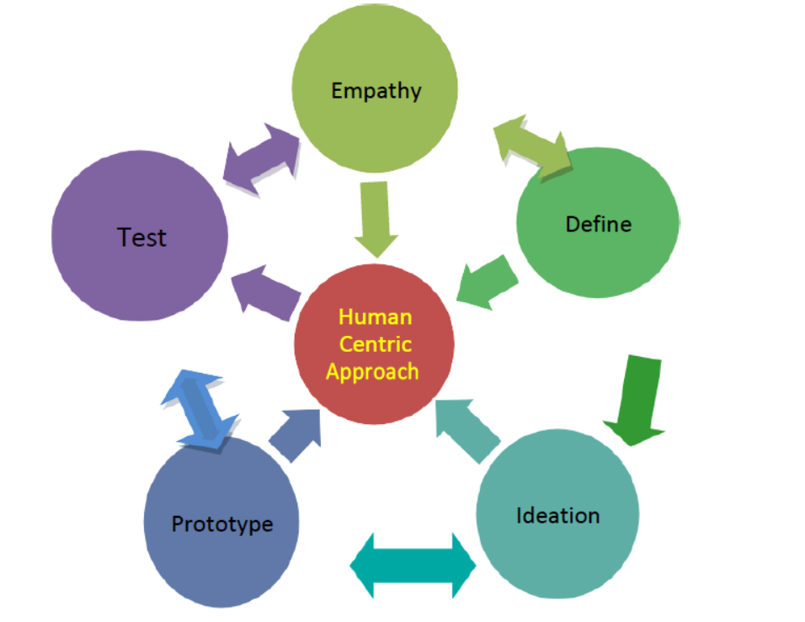

**1. Empathize**

In this first stage, the designer observes consumers to gain a deeper understanding of how they interact with or are affected by a product or issue. The observations must happen with empathy, which means withholding judgment and not imparting preconceived notions of what the consumer needs. Observing with empathy is powerful because it can uncover issues the consumer didn’t even know they had or that they could not themselves verbalize. From this point, it’s easier to understand the human need for which you are designing.

**2. Define**

In this second stage, you gather your observations from the first stage to define the problem you’re trying to solve. Think about the difficulties your consumers are brushing up against, what they repeatedly struggle with, and what you’ve gleaned from how they’re affected by the issue. Once you synthesize your findings, you are able to define the problem they face.

**3. Ideate**

The next step is to brainstorm ideas about how to solve the problem you’ve identified. These ideation sessions could be in a group, where your team gathers in an office space that encourages creativity and collaboration, an innovation lab, or can be done solo. The important part is to generate a bunch of different ideas. At the end of this process, you’ll come up with a few ideas with which to move forward.

**4. Prototype**

This is the stage that turns ideas into an actual solution. Prototypes are not meant to be perfect. The point of a prototype is to come out quickly with a concrete version of the idea to see how it is accepted by consumers. Examples of prototypes include a landing page to test consumer desire for a product or a video that demonstrates streamlined logistic processes.

**5. Test**

Once you give a prototyped solution to consumers, you must observe how they interact with it. This testing stage is the one in which you collect feedback on your work.

**3. Explain the Design Thinking process with tools and techniques.**

**1. Design Thinking – Intro**

• Intro to Design Thinking methodology

• Importance

•Design Process

•Design Elements

**2. Domain Identification**

• Select your area of interest for design project

• Branch specific or General domain

**3. Observation**

•AEIOU Framework

• Role Playing

• Interview

•And many more methods available

**4. Empathy**

• Identify Unarticulated/Unmet needs of User

• Pleasure and Pain points

• Story telling

**5. Design Mind Mapping Problem**

•Define the Problem Statement based on empathy of User

• Right problem leads you to right solution

**6. Ideation**

• Multiple ideas/solutions for problem

• Refine the problem statement with possible solutions

• Opportunity mapping

**7. Concept Finalization**

• After combining and refining, finally select the concept for your problem statement

**8. Dirty Mock -ups**

• Very early & rough prototype

• Made up of paper, cardboard, thermocole etc. whichever material is available

**9. Product Development**

• Functions

• Features

•User Expereince

• Components

**10. Customer Feedback**

• Revalidation

• Reject

• Redesign

• Retain

**11. Pre-Design(Learning Need Matrix)**

• System level design/Project Plan

• Identify Learning requirement to complete project

**12. Prototype**

• Sequential prototyping

• Iterations with all possible modifications

**13. Test/Analysis**

• Analysis

• Simulation

• Test your design in real environment and then iterate if.

Literature Survey

E-Commerce website: This is a website to buy electronic gadgets online. Our website provides the best prices of the desired product for the customers. There are discount and many attractive offers available on the products. The customers could also compare the prices of products of various companies and then decide the optimal product for them. There is description of each and every product available so the customer could get enough information about the product on the website itself. There are various electronic gadgets like mobile, fridge, TV’s, etc.

The regular buyers also give their valuable comments and rating of each products so each new customer can look at that to benefit them. The critics review’s also play a vital role in the selection process.

Our website is the main attraction for IT companies, youth, professionals and many more.

We provide the facility of adding the desired product to the cart and review later before buying. The customer also gets the email after confirming the product to be sold. So there are no chances of error in shopping process. We ensure delivery to desired areas also.

**Case study of existence solution**

The case study report of similar applications.

**First existing Solution: Flipcart**

**Methodology:**

It is also an E-Commerce website to buy the desired electronic products at reasonable prices.

**Pros:**

Delivery at every place on desired time

**Cons:**

Personal customer service is not available

**Second existing Solution: Amazon**

**Methodology:**

It is also an E-Commerce website to buy the desired electronic products at reasonable prices.

**Pros:**

Delivery at every place on desired time and wide range of products.

**Cons:**

The delivered product is much different than what it seems.

**Design Considerations for detail design –DFD,**

**ER diagrams**

**DFD**

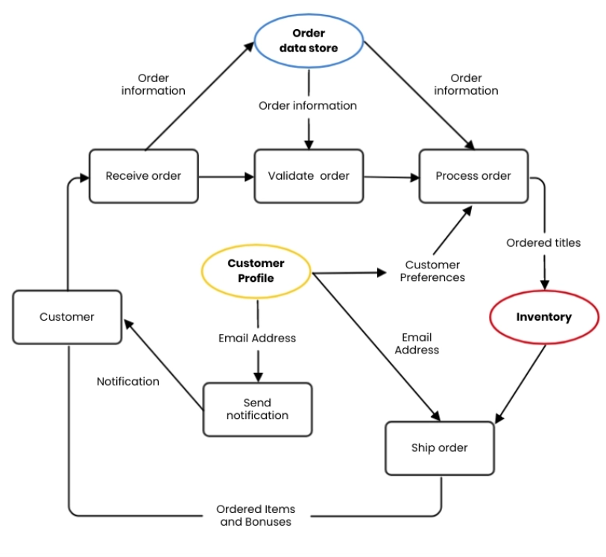

**ER DIAGRAM**

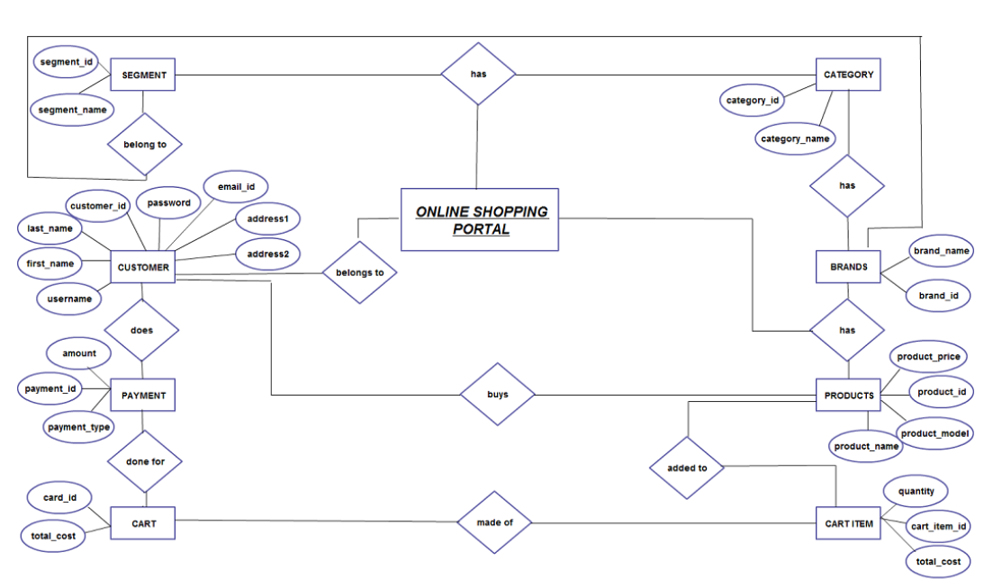

**CANVASES**

**AEIOU CANVAS**

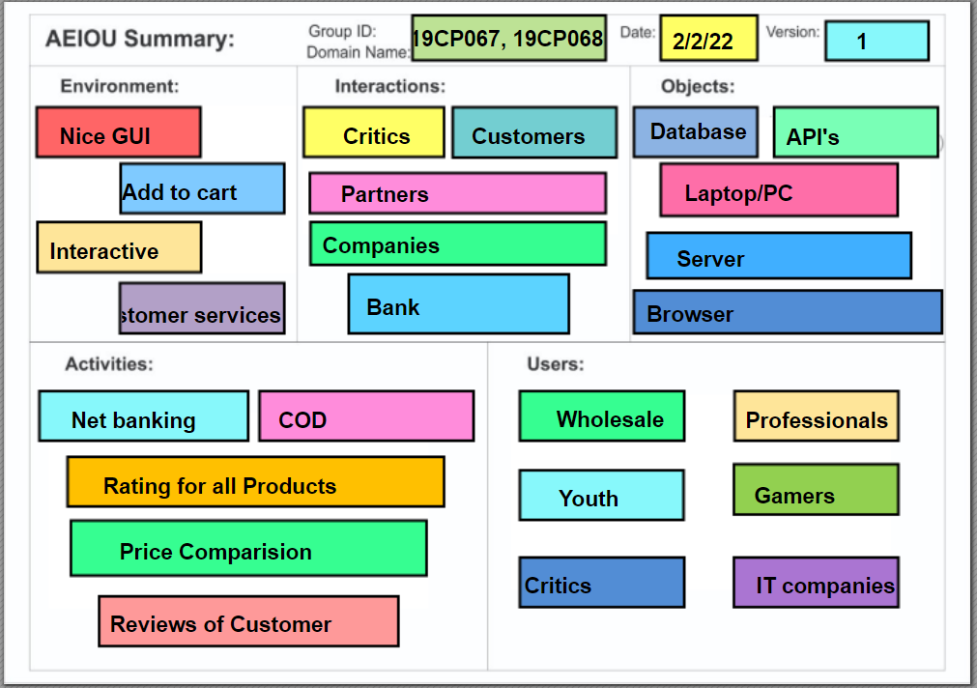

**EMPATHY CANVAS**

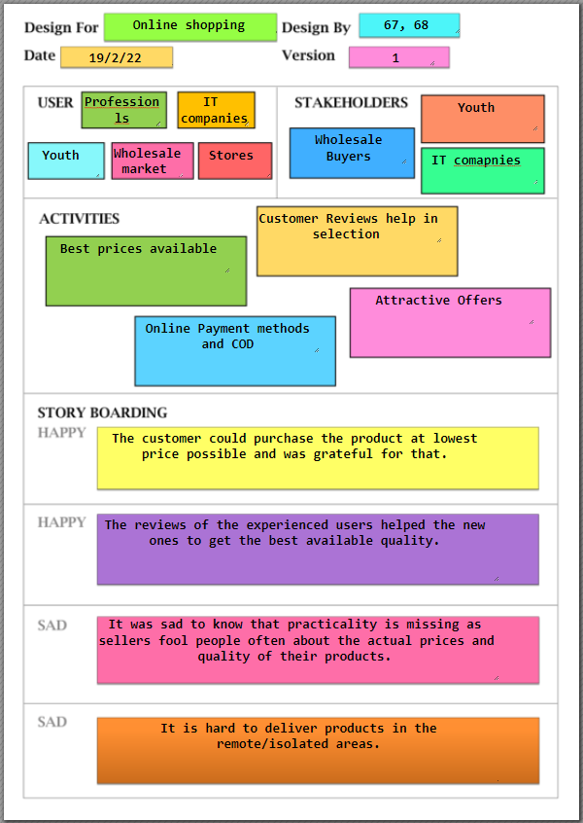

**IDEATION CANVAS**

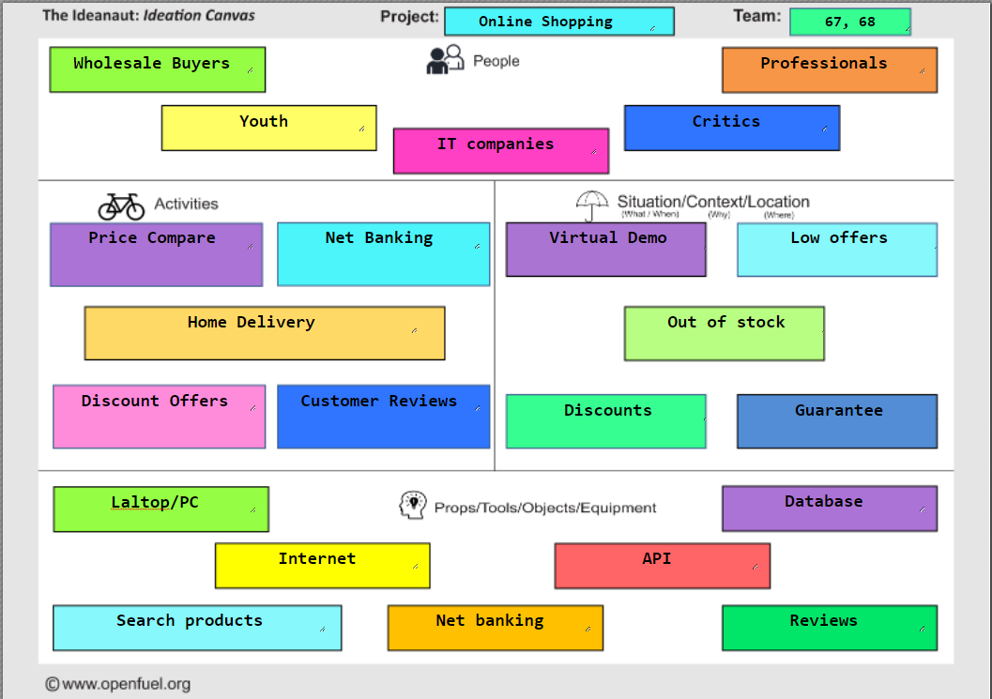

**PRODUCT DEVELOPMENT CANVAS**

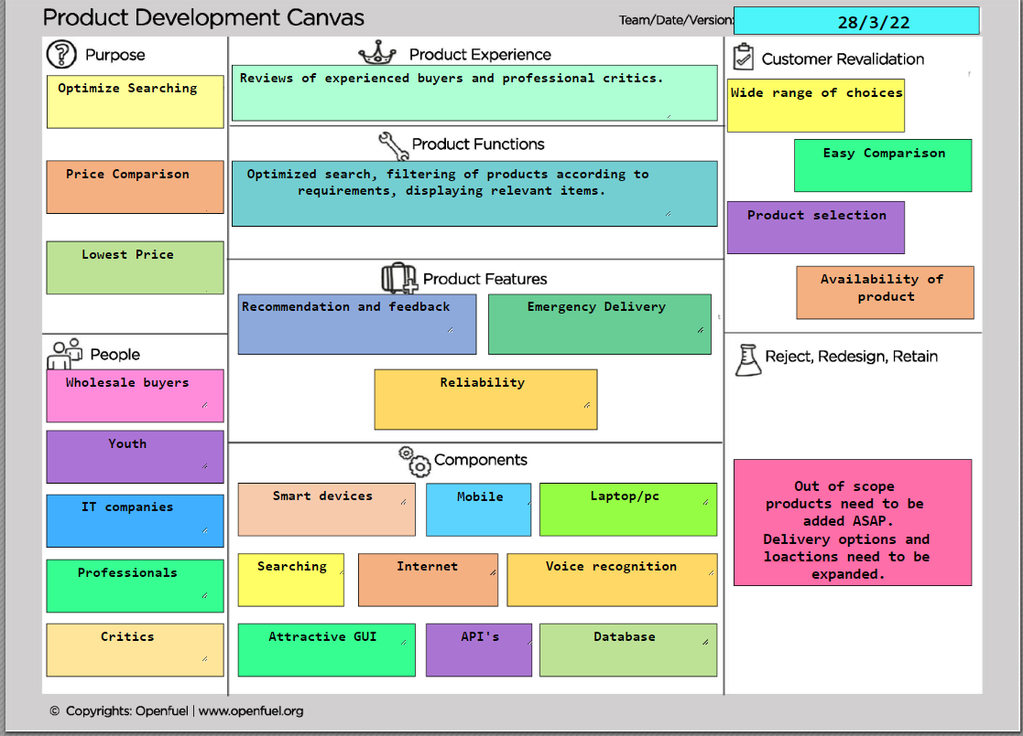

**IMPLEMENTATION**

**Home Page:**

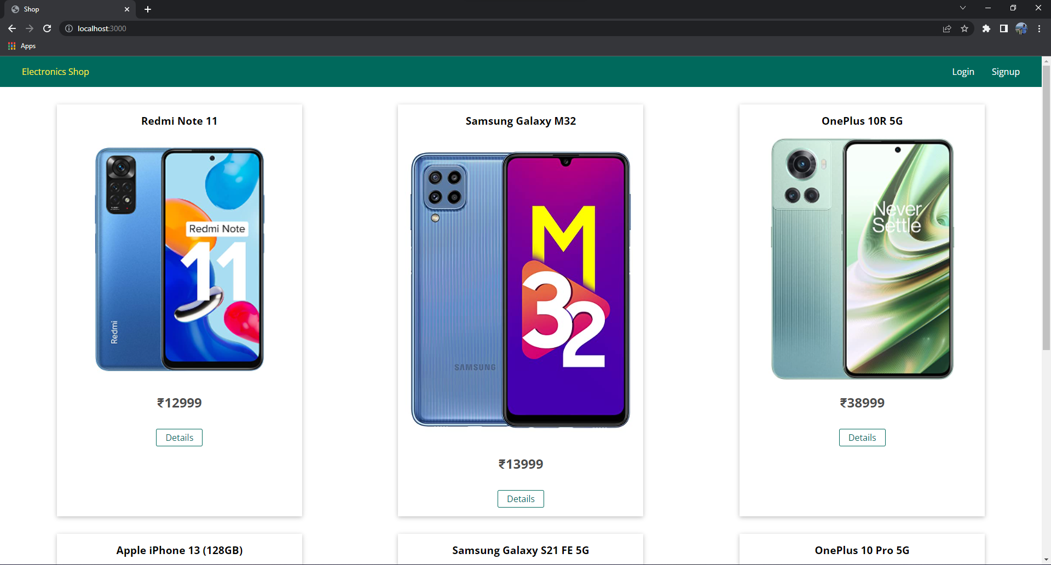

**Login Page:**

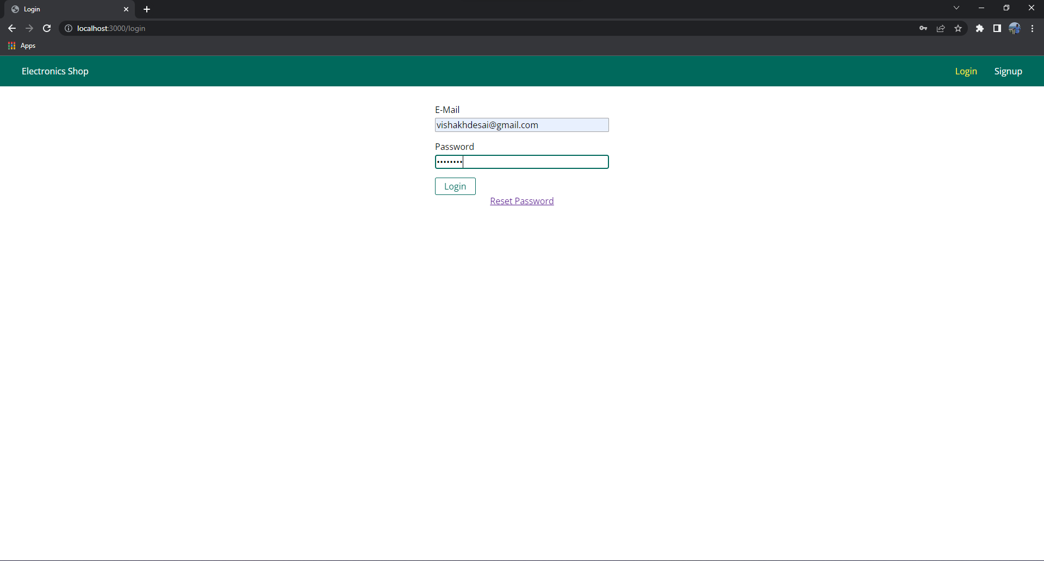

**Home Page after Login:**

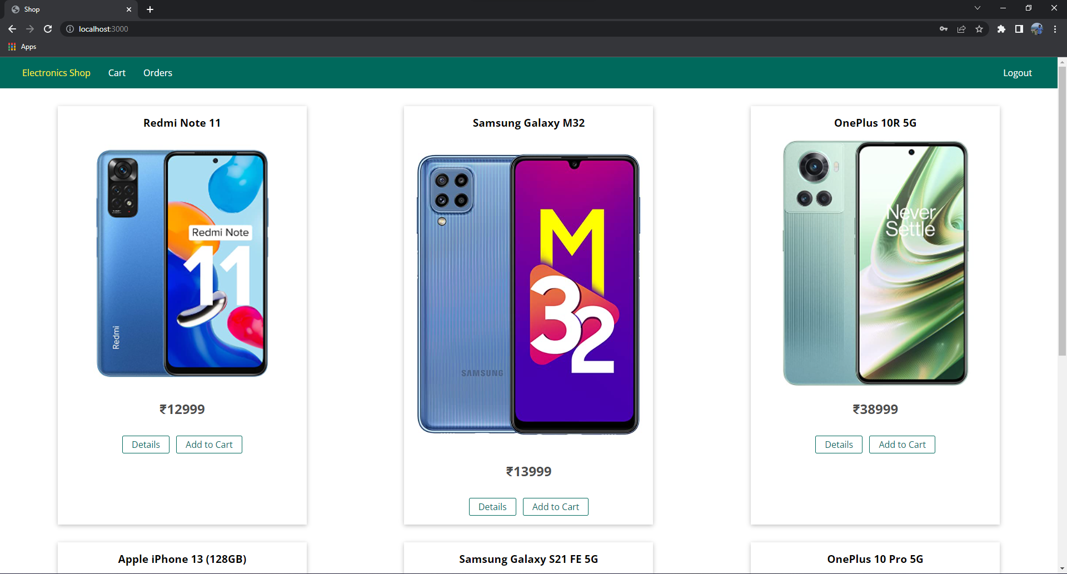

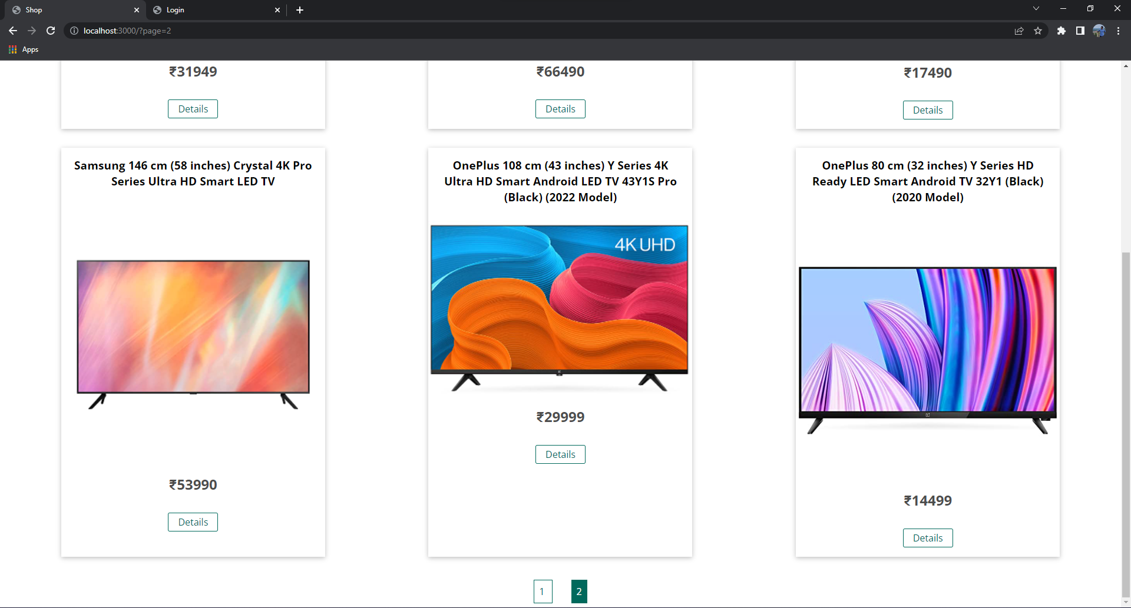

**Cart:**

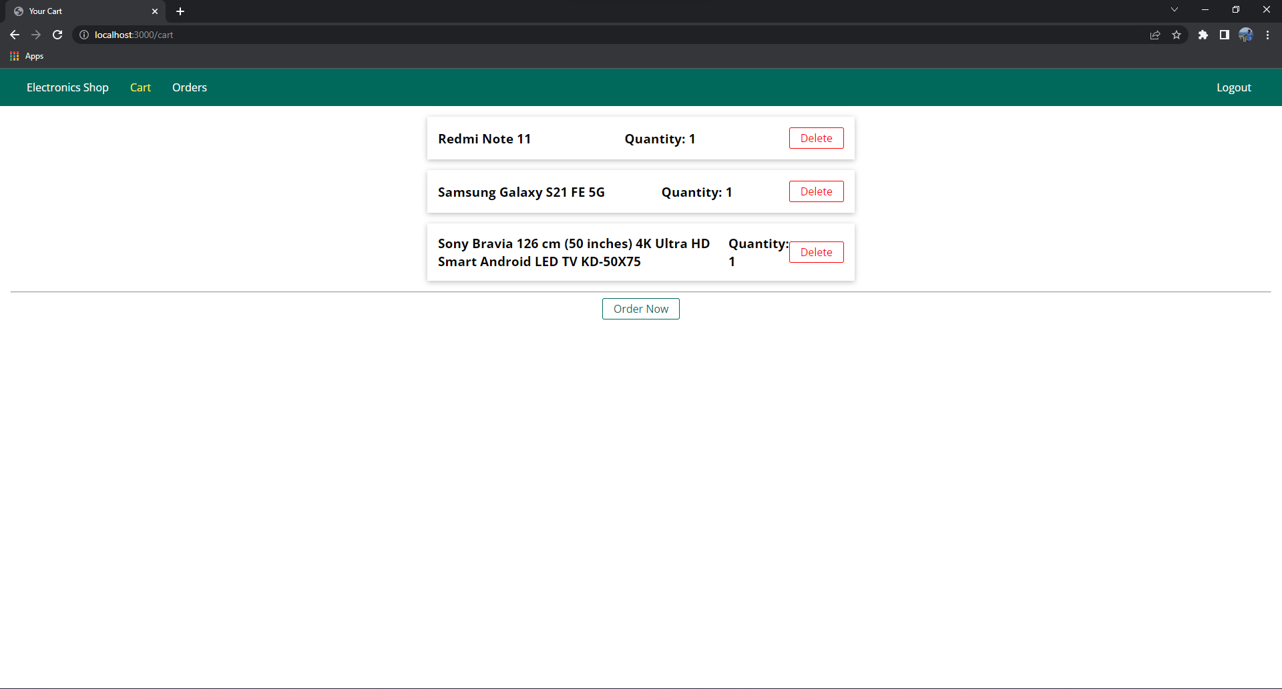

**Payment Gateway (Stripe):**

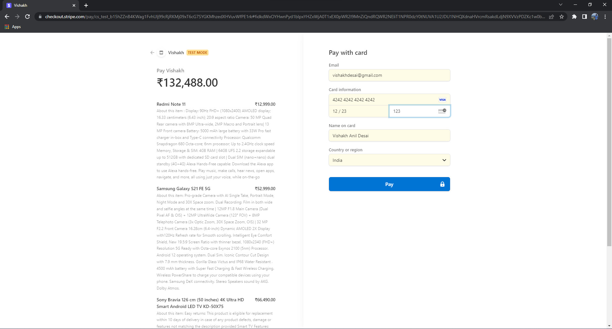

**Orders Page:**

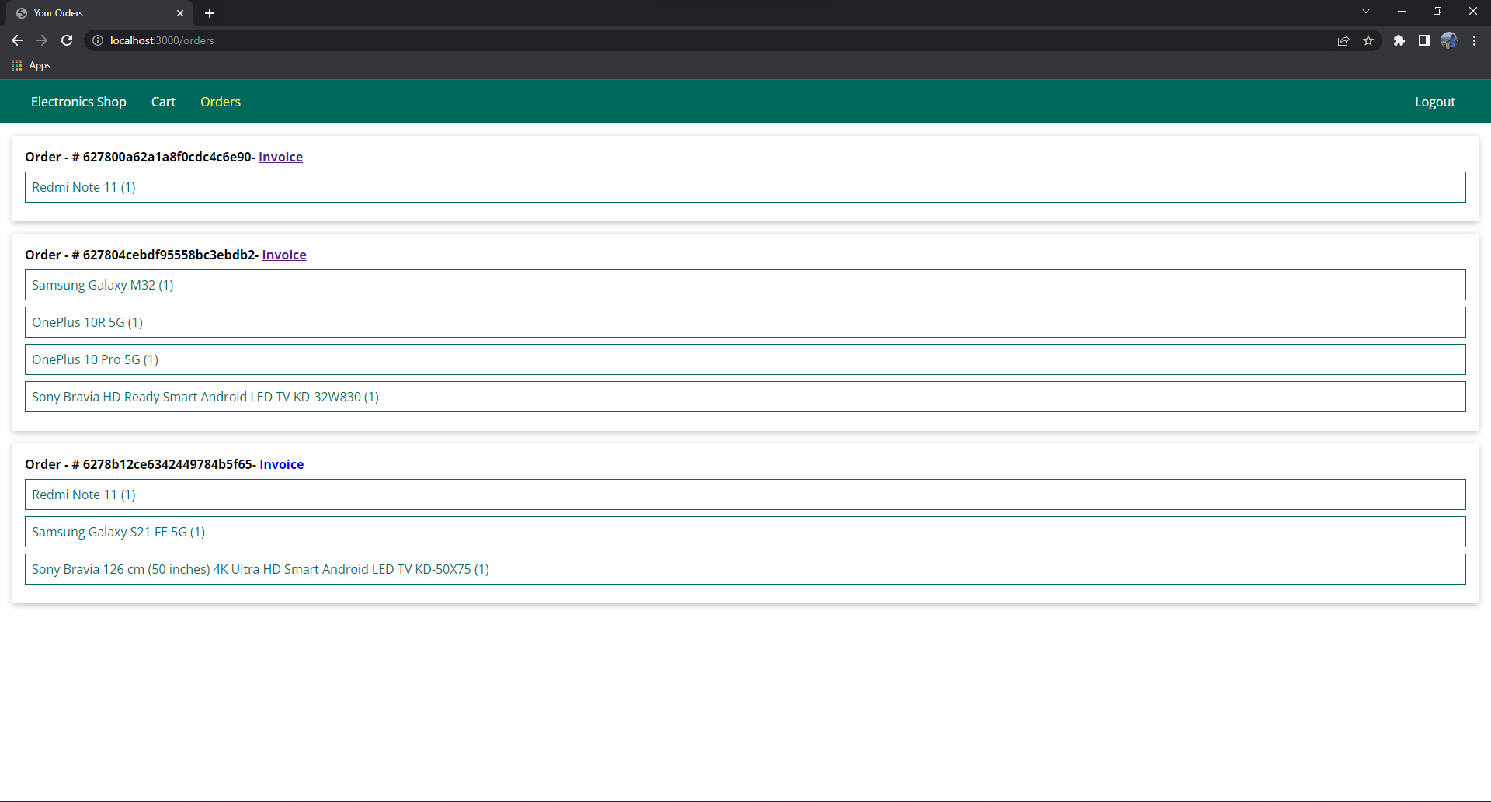

**Invoice (using PDF kit):**

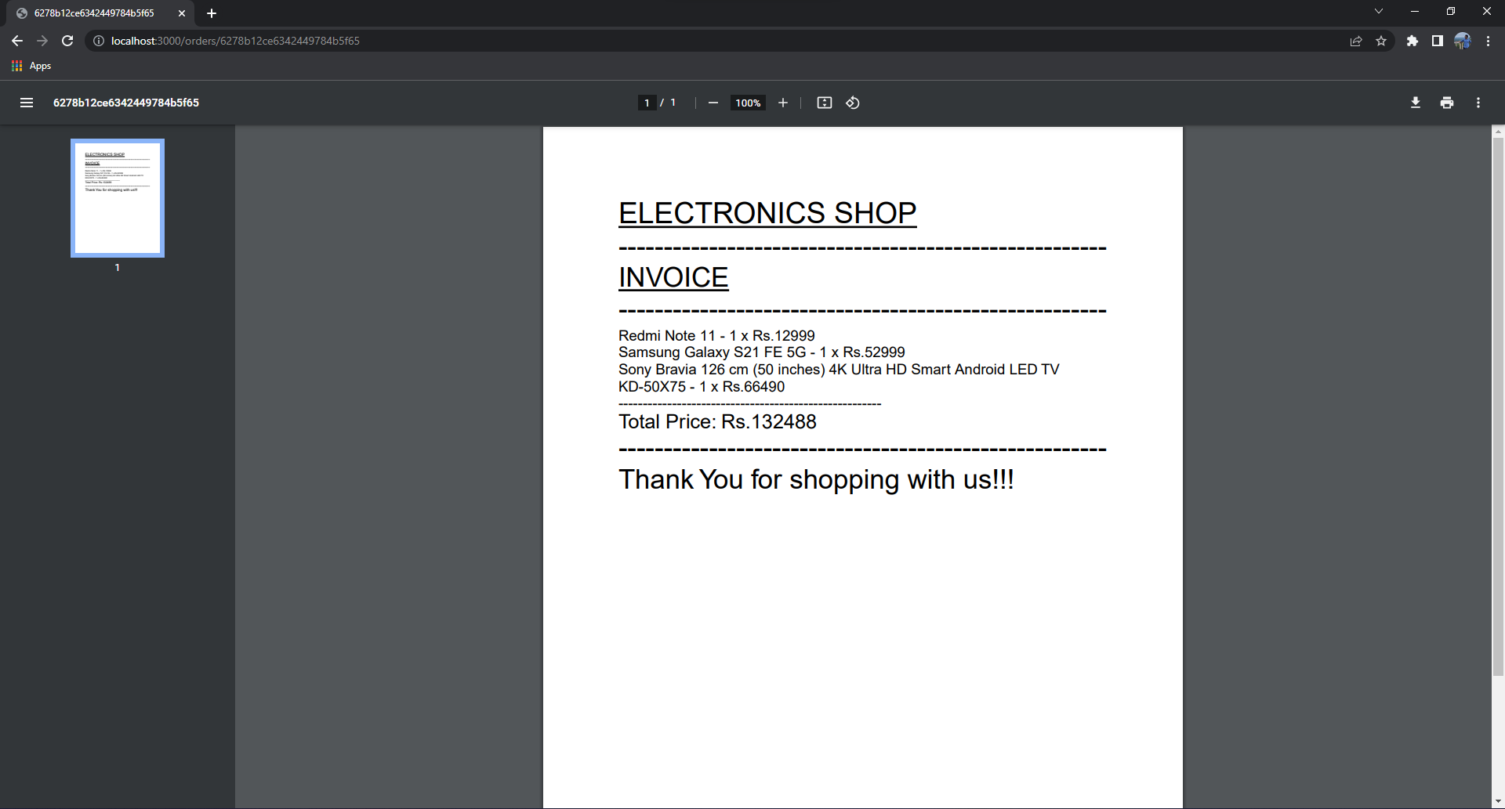

**Reset Password Page:**

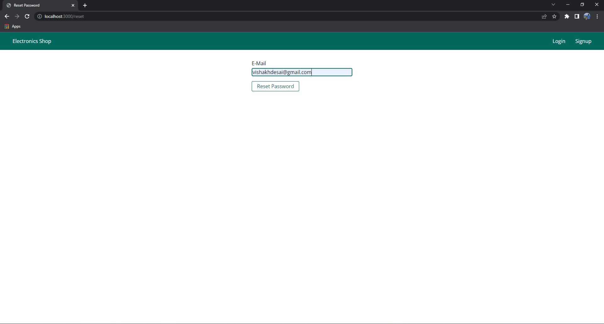

**Email containing the link to update password:**

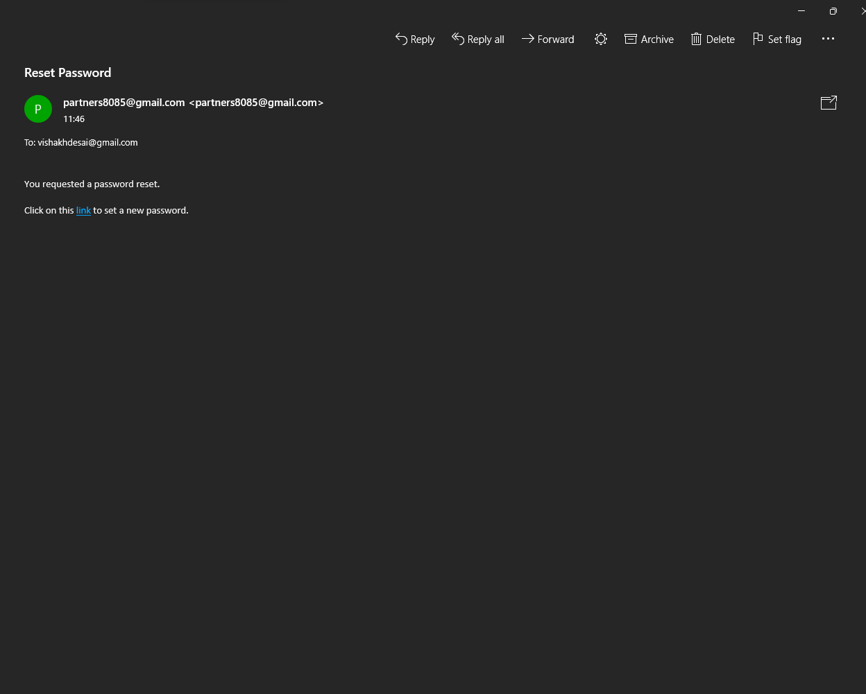

**Password update page:**

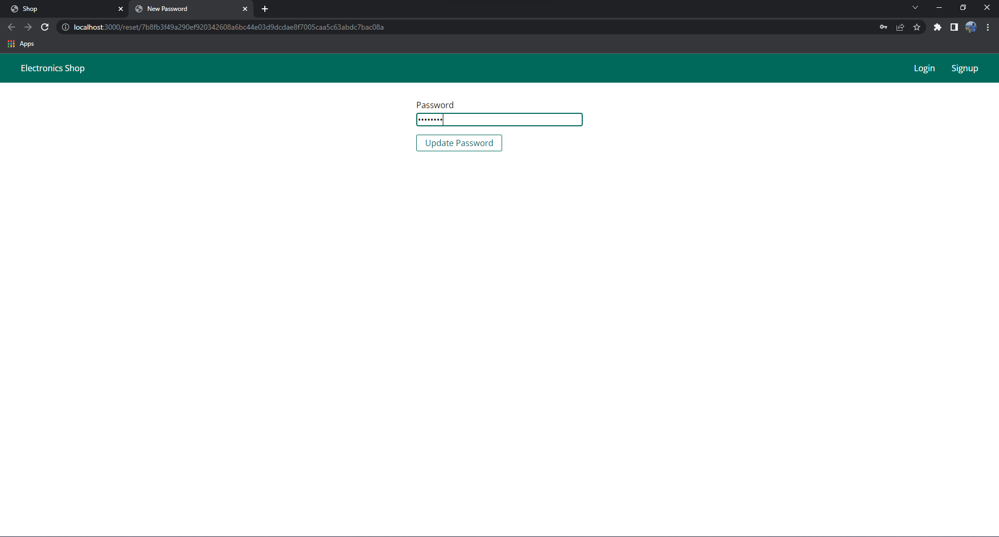

**Conclusion and Future scope**

**The customers are able to buy the desired products with enough information of what they are buying. They can choose the most optimal product for them after comparing their chosen product with the similar other models. The critics and customer review helps them in the selection process.**

**In the modern era no one has the time to go to the shop and get the information about products. Also the selection process for various companies consumes very much time. Our website provides solution to that problem and hence the customers will tend to online mode of shopping more than ever.**

**Future Improvements**

**The improvements may include:**

* **We are yet to consider delivery at each and every household.**
* **Get more companies affiliated to our website**
* **Improve the database record**